Stop and Go 555   
Test Build Instructions

**Directions:**A text description will be given:   
1) Insert 100K Ohm Resistor, from Base (B) of each transistor (Column 4), to Positive (Red) Rail  
  
Then a more concise grid based description will be given:  
100K Ohm Resistor A4 to PR  
100K Ohm Resistor J4 to NR  
Where PR is Positive Rail, and NR is Negative Rail  
  
In the case of polarized components, + and – will be used, referring to legs on the component.  
LED A10- to PR+  
LED J10+ to NR-  
In the first case, LED short leg goes into A10, while long leg goes into Positive Rail.

Note that for clarity, leads have been trimmed to reduce complexity.  
It would be a good idea not to trim leads as they may be required in a final design.  
  
**Parts List:**100k ohm Resistor x 2, Brown Black Yellow  
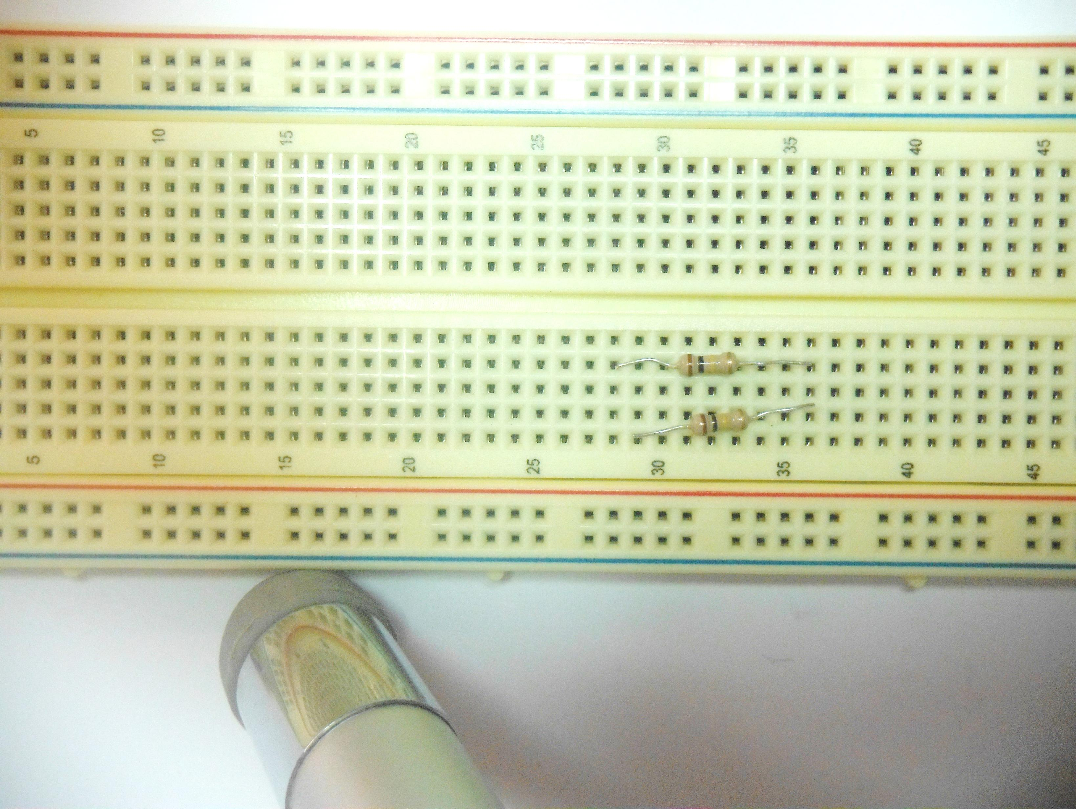  
  
470 ohm Resistor x 2 Yellow Violet Brown  
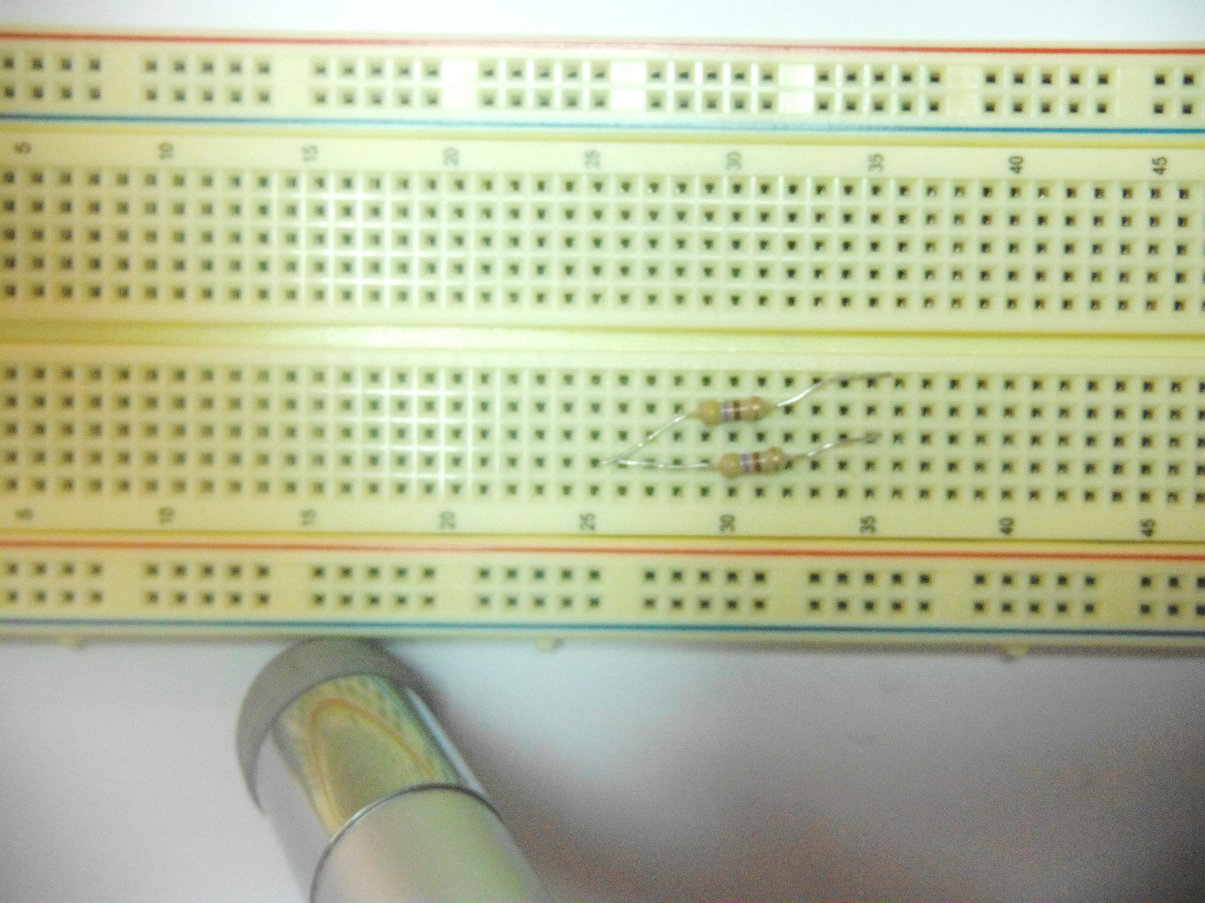

10uf Capacitor  
Polarized Long Lead is Positive  
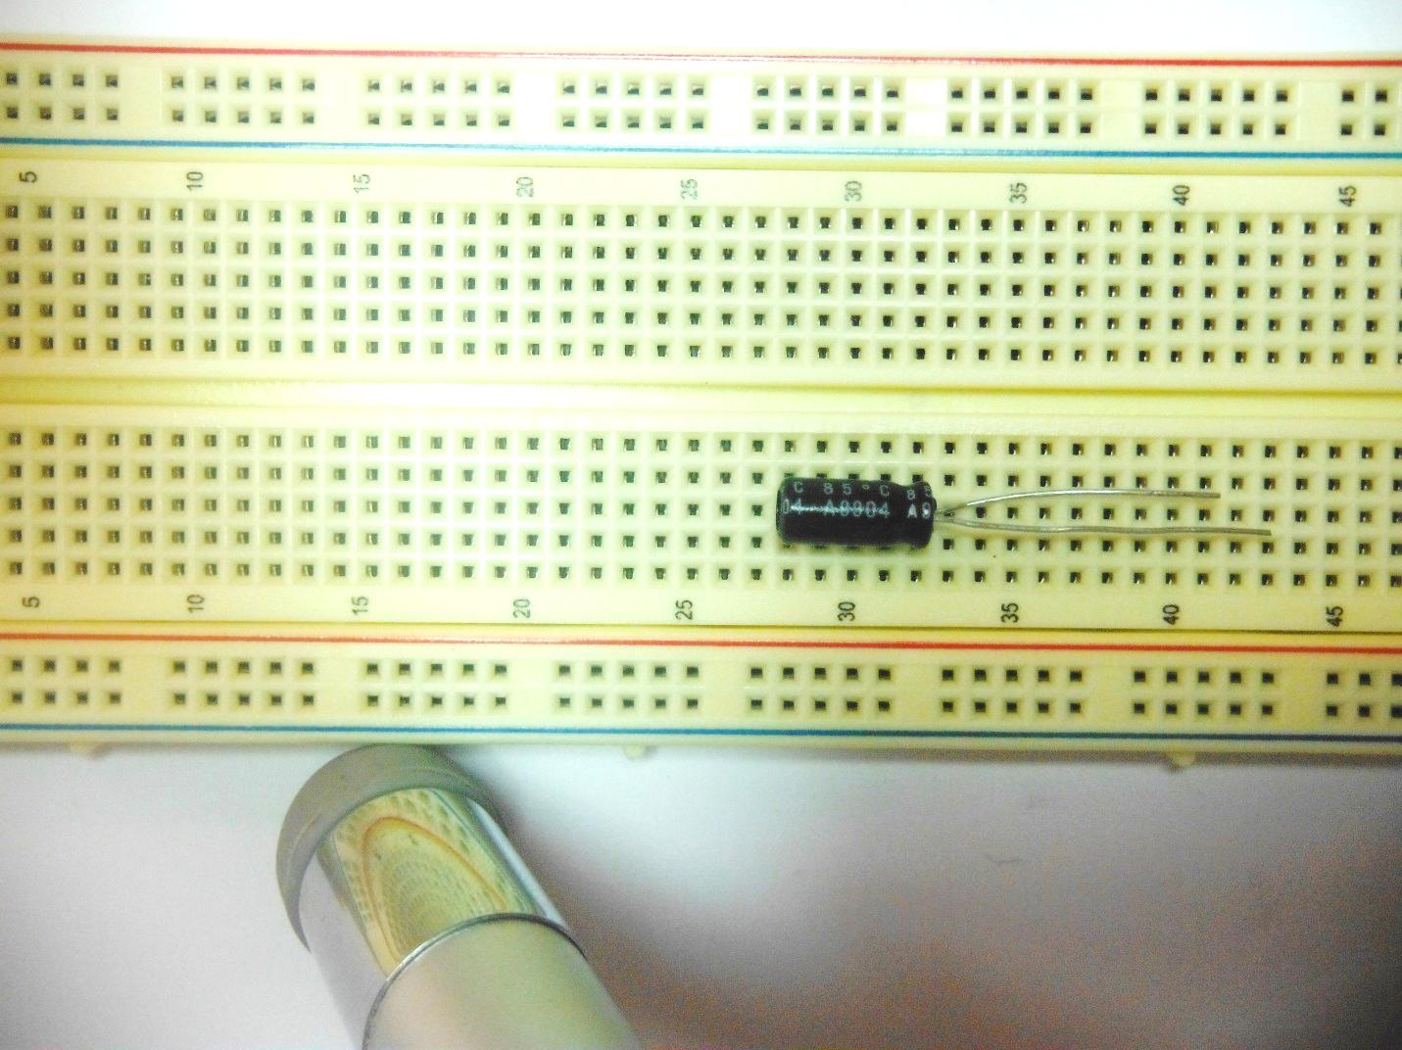  
  
LEDs, Red and Green  
Polarized: Long Lead is Positive  
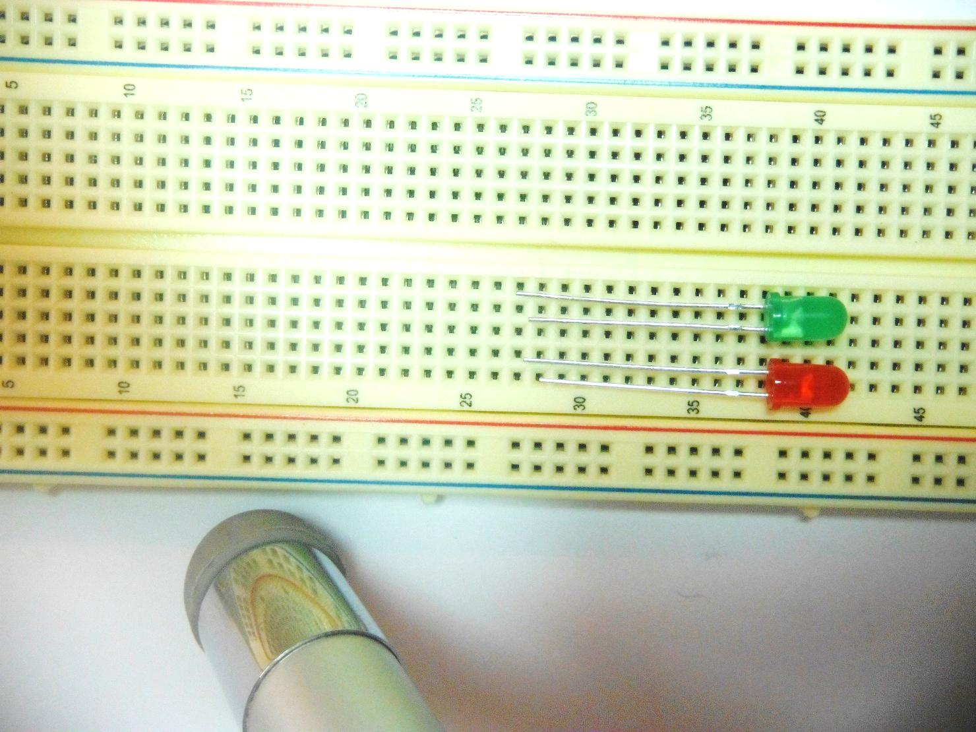  
  
55 Timer IC  
Pin 1 is to the left of the notch.  
Pin Out:  
 8 7 6 5  
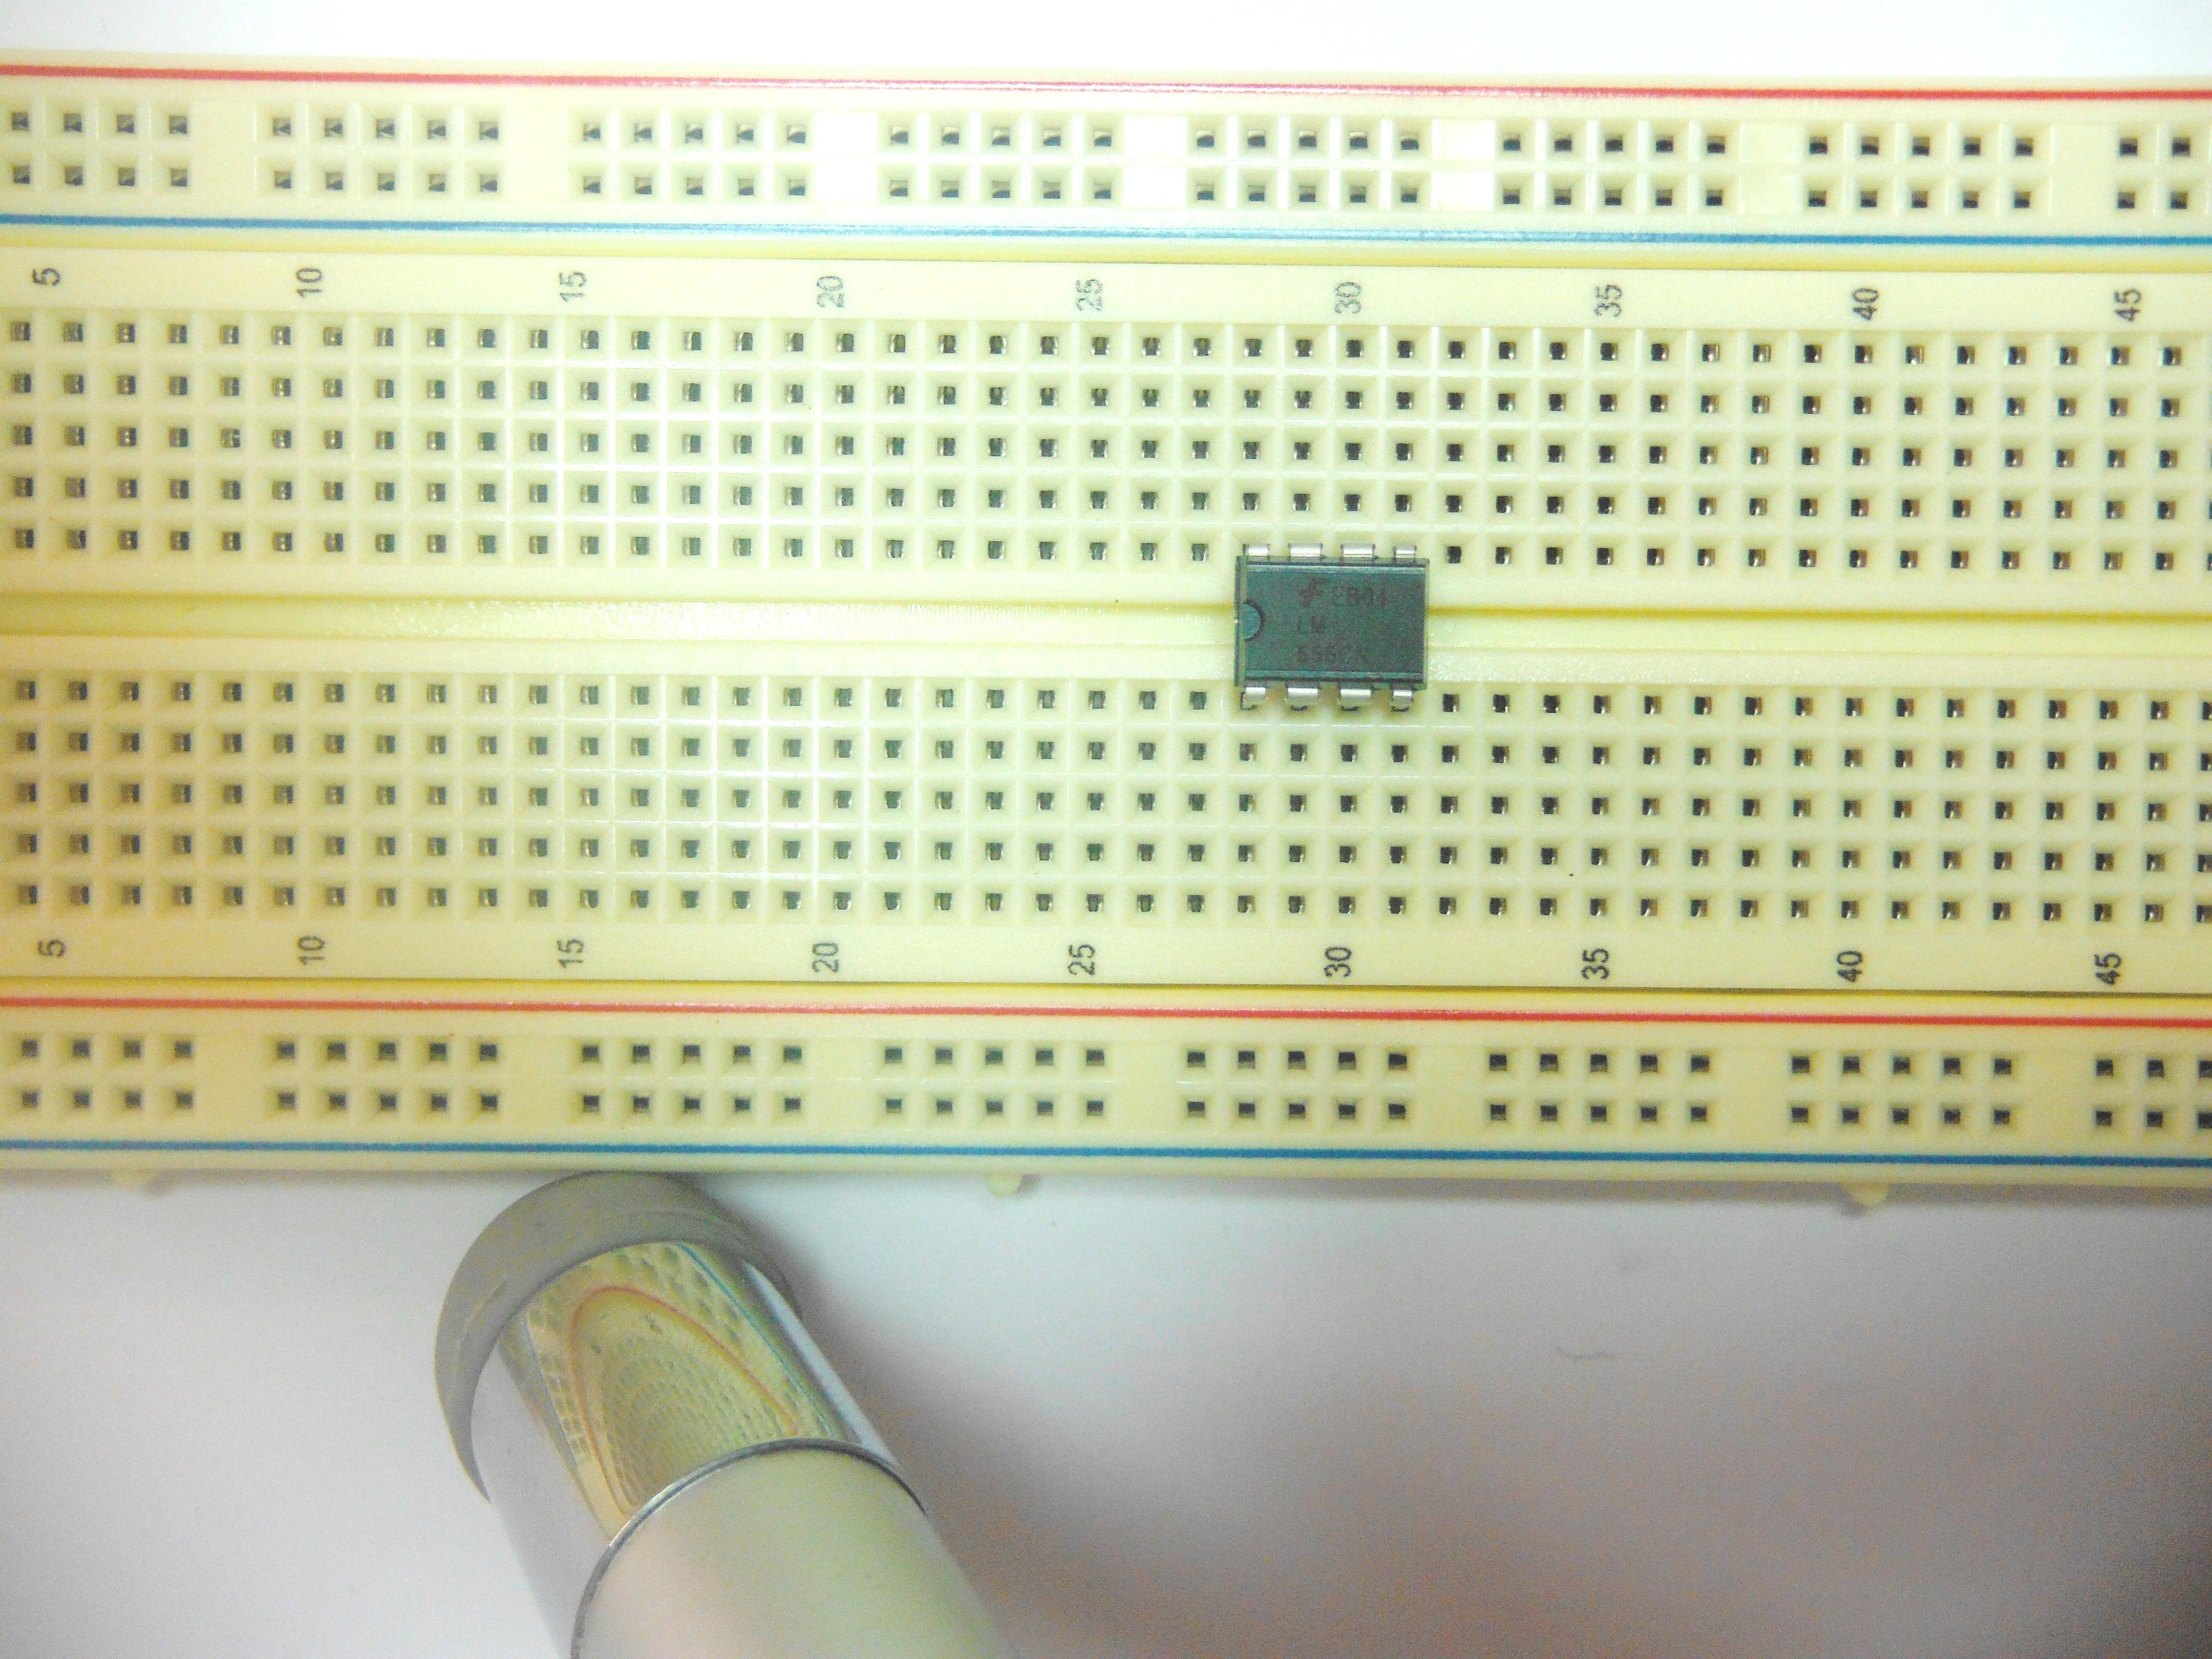  
 1 2 3 4  
  
Jumper Wire x4, approx. 40mm  
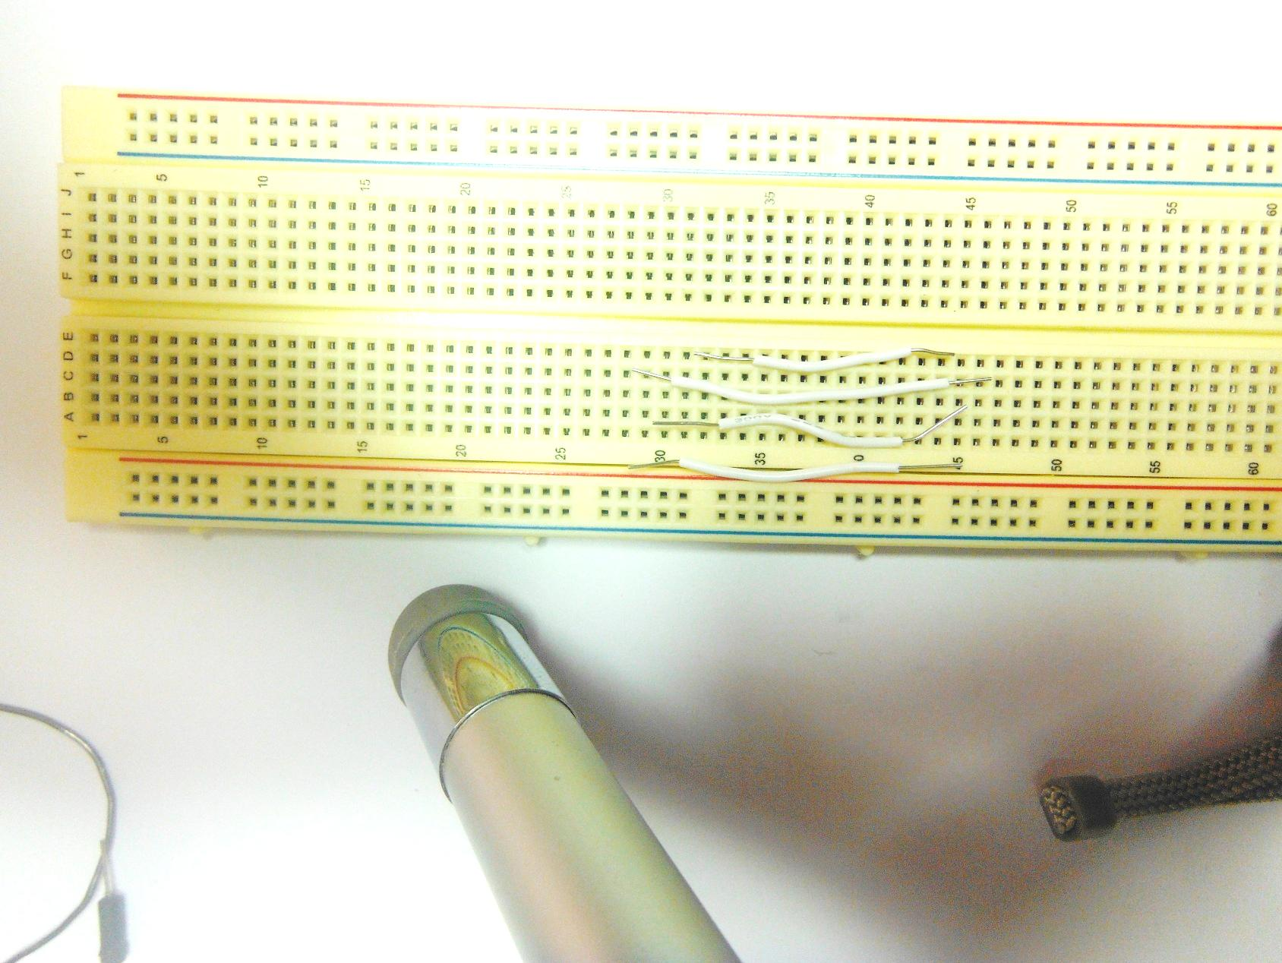

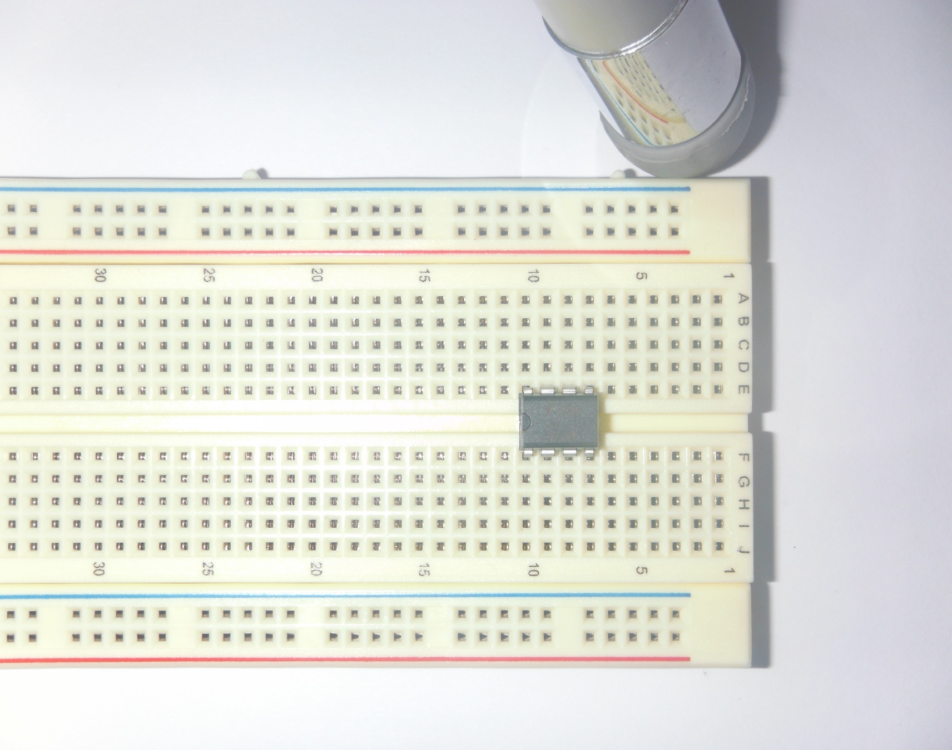9V Battery and Clip  
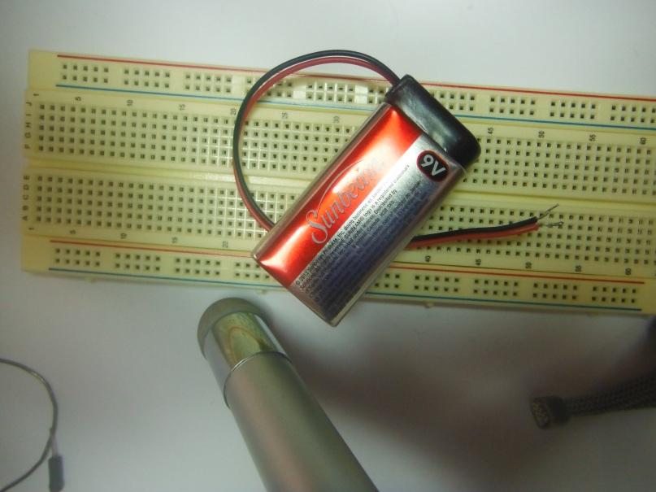

1. Start with lowest number on breadboard columns to top left.  
   Insert 555 IC with pin 1 at F10, pin 5 at E7.

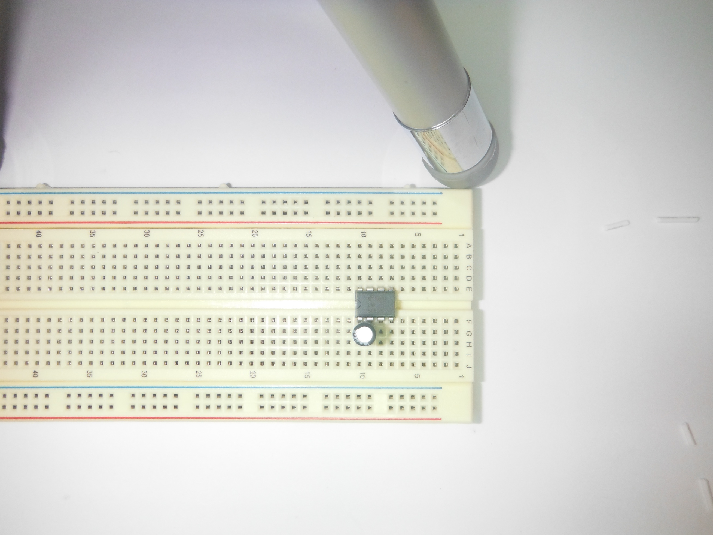

2.) Insert 10uf Capacitor, Long Lead at Pin 2, Short Lead at Pin 1.  
 10uf Capacitor G10- to G9+.

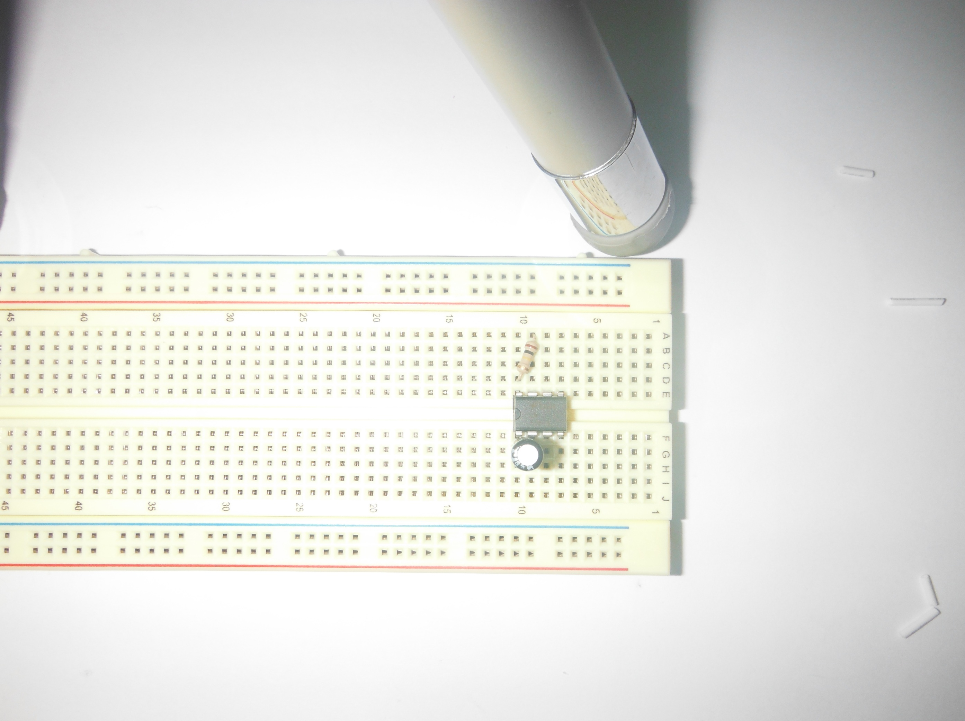3.) Insert 100k Ohm Resistor (Brown, Black, Yellow) from Pin 8 to Pin 7.  
100k ohm resistor from A9 to D10.

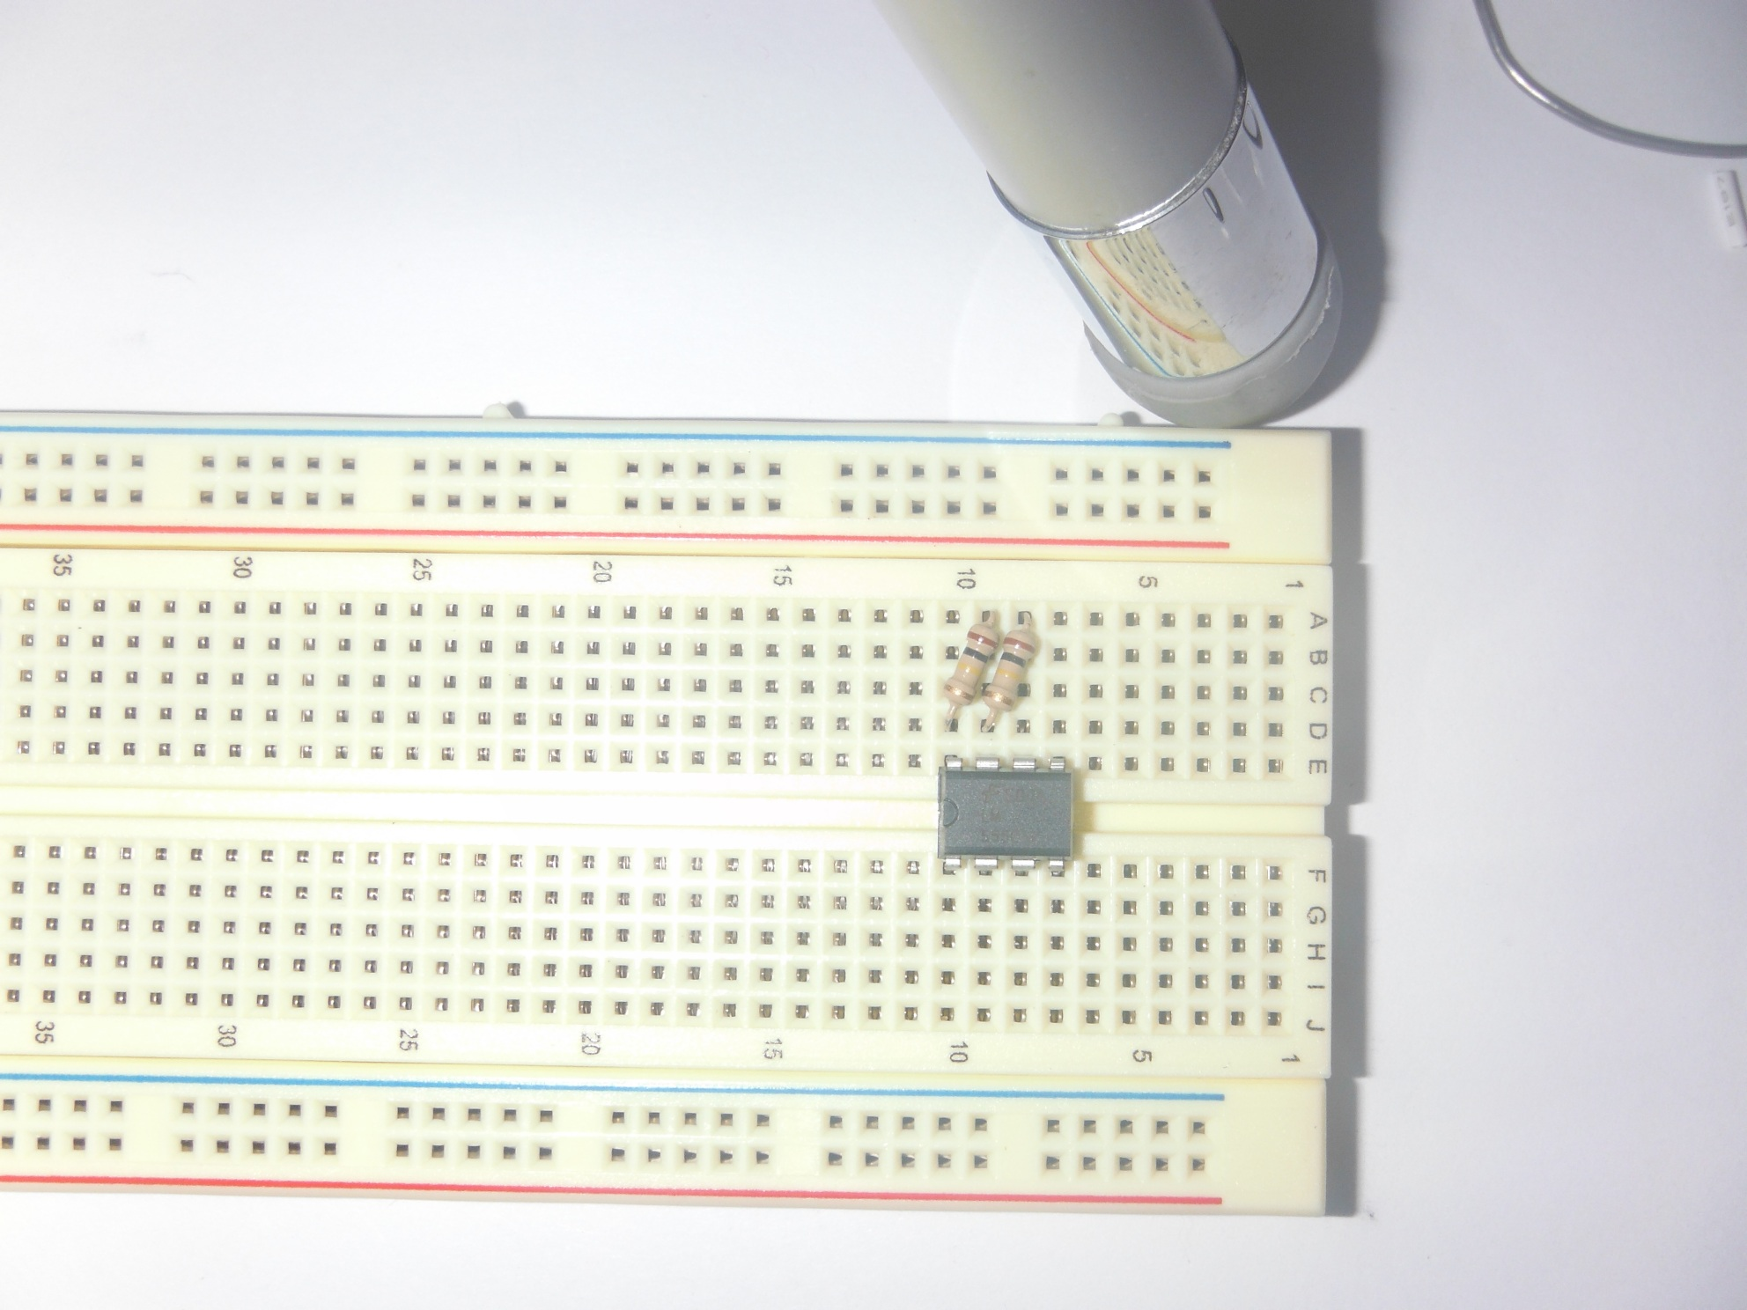  
  
  
  
  
  
  
  
  
  
  
4) Insert 100k Ohm Resistor (Brown, Black, Yellow) from Pin 7 to Pin 6.  
100k ohm resistor from A8 to D9.

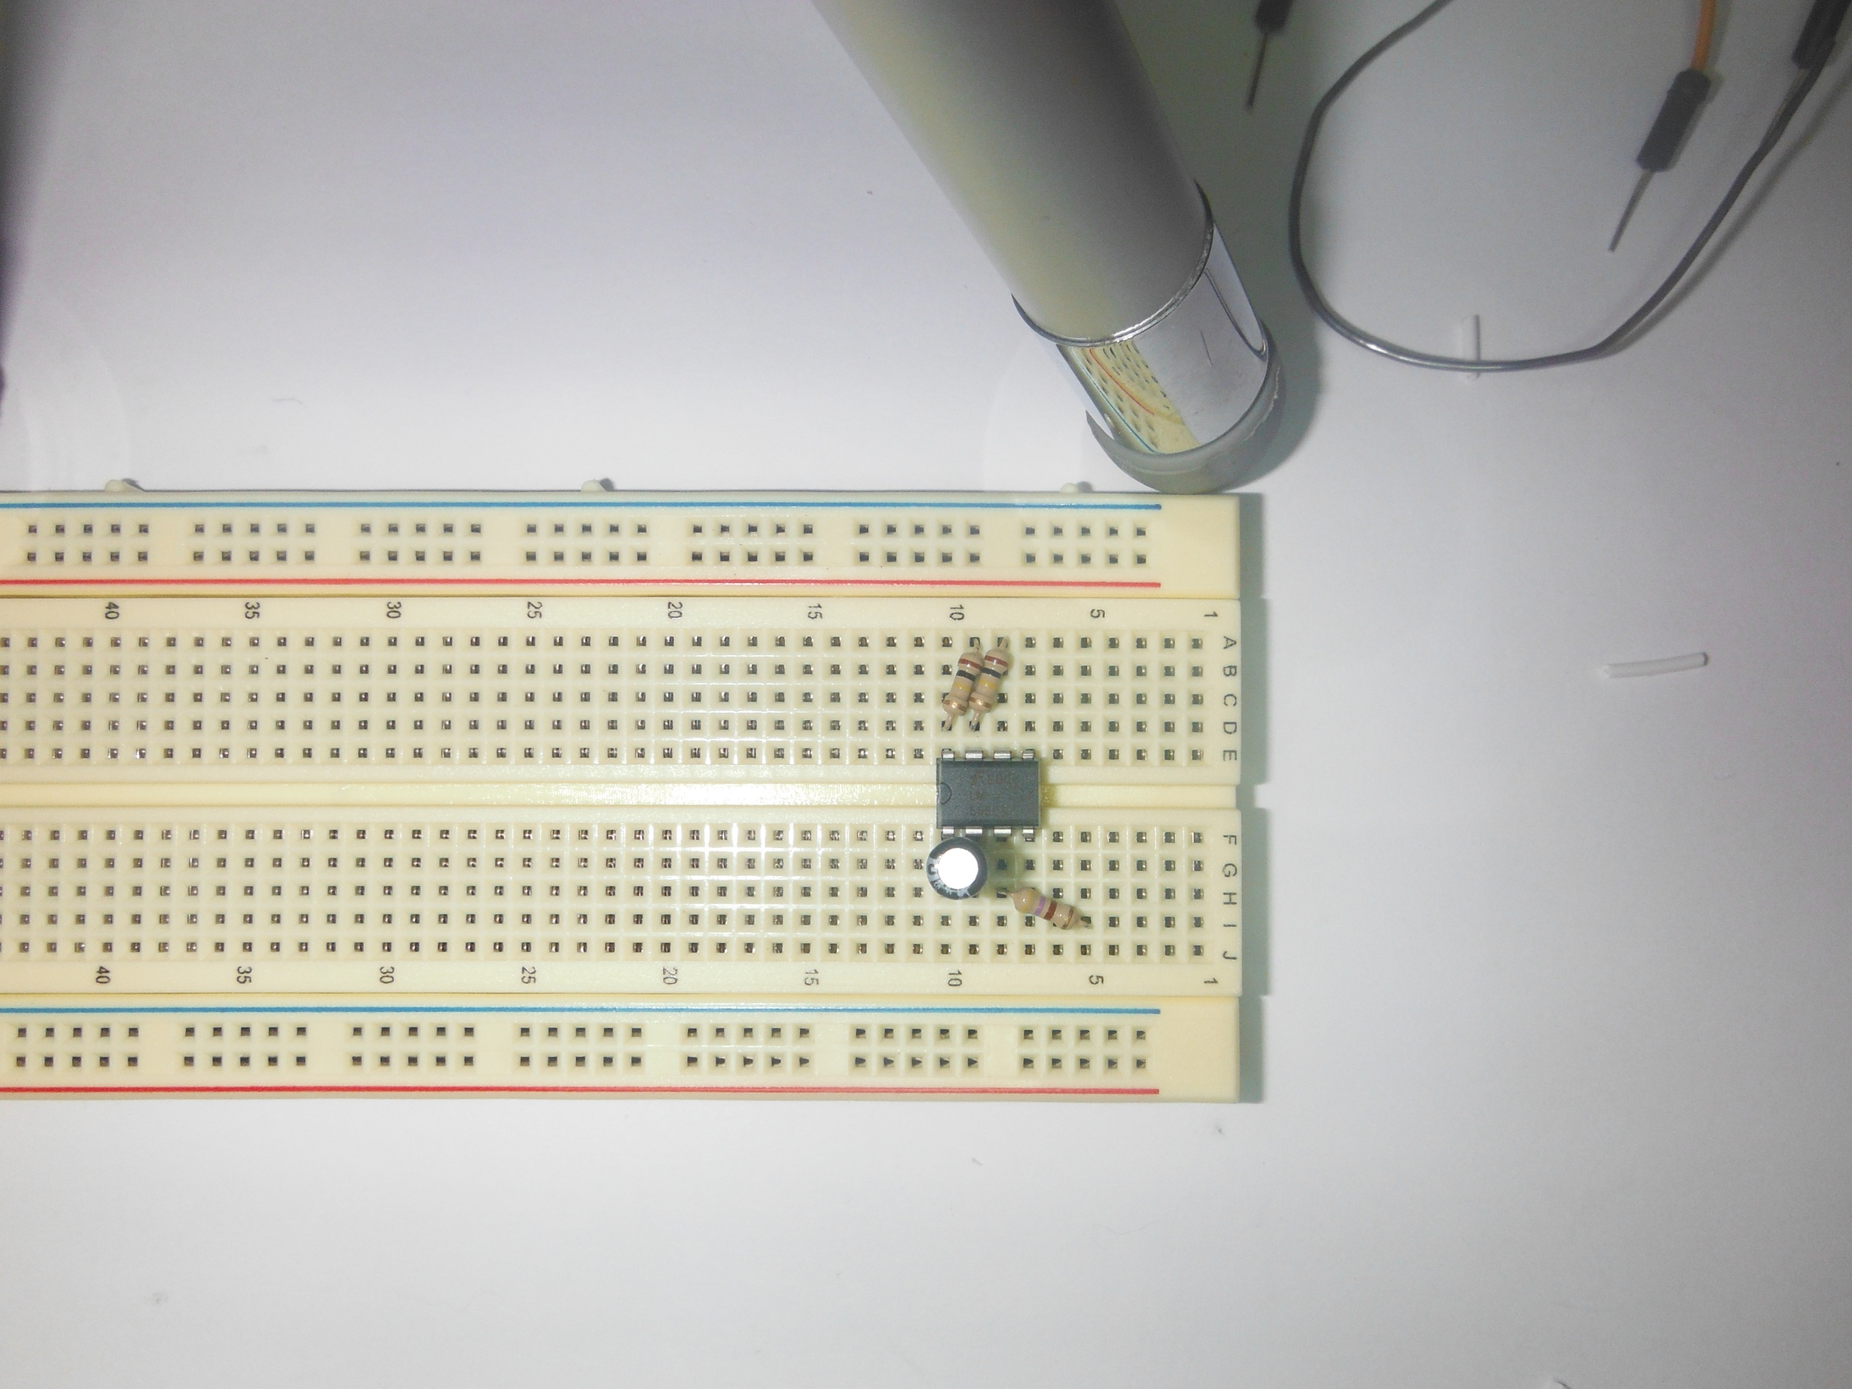

5) Insert 470 Ohm Resistor from Pin 3 to I5.  
470 Ohm Resistor G8 to I5.

6) Insert 470n Ohm Resistor from Pin 3 to E5.  
470 ohm Resistor G8 to E8.

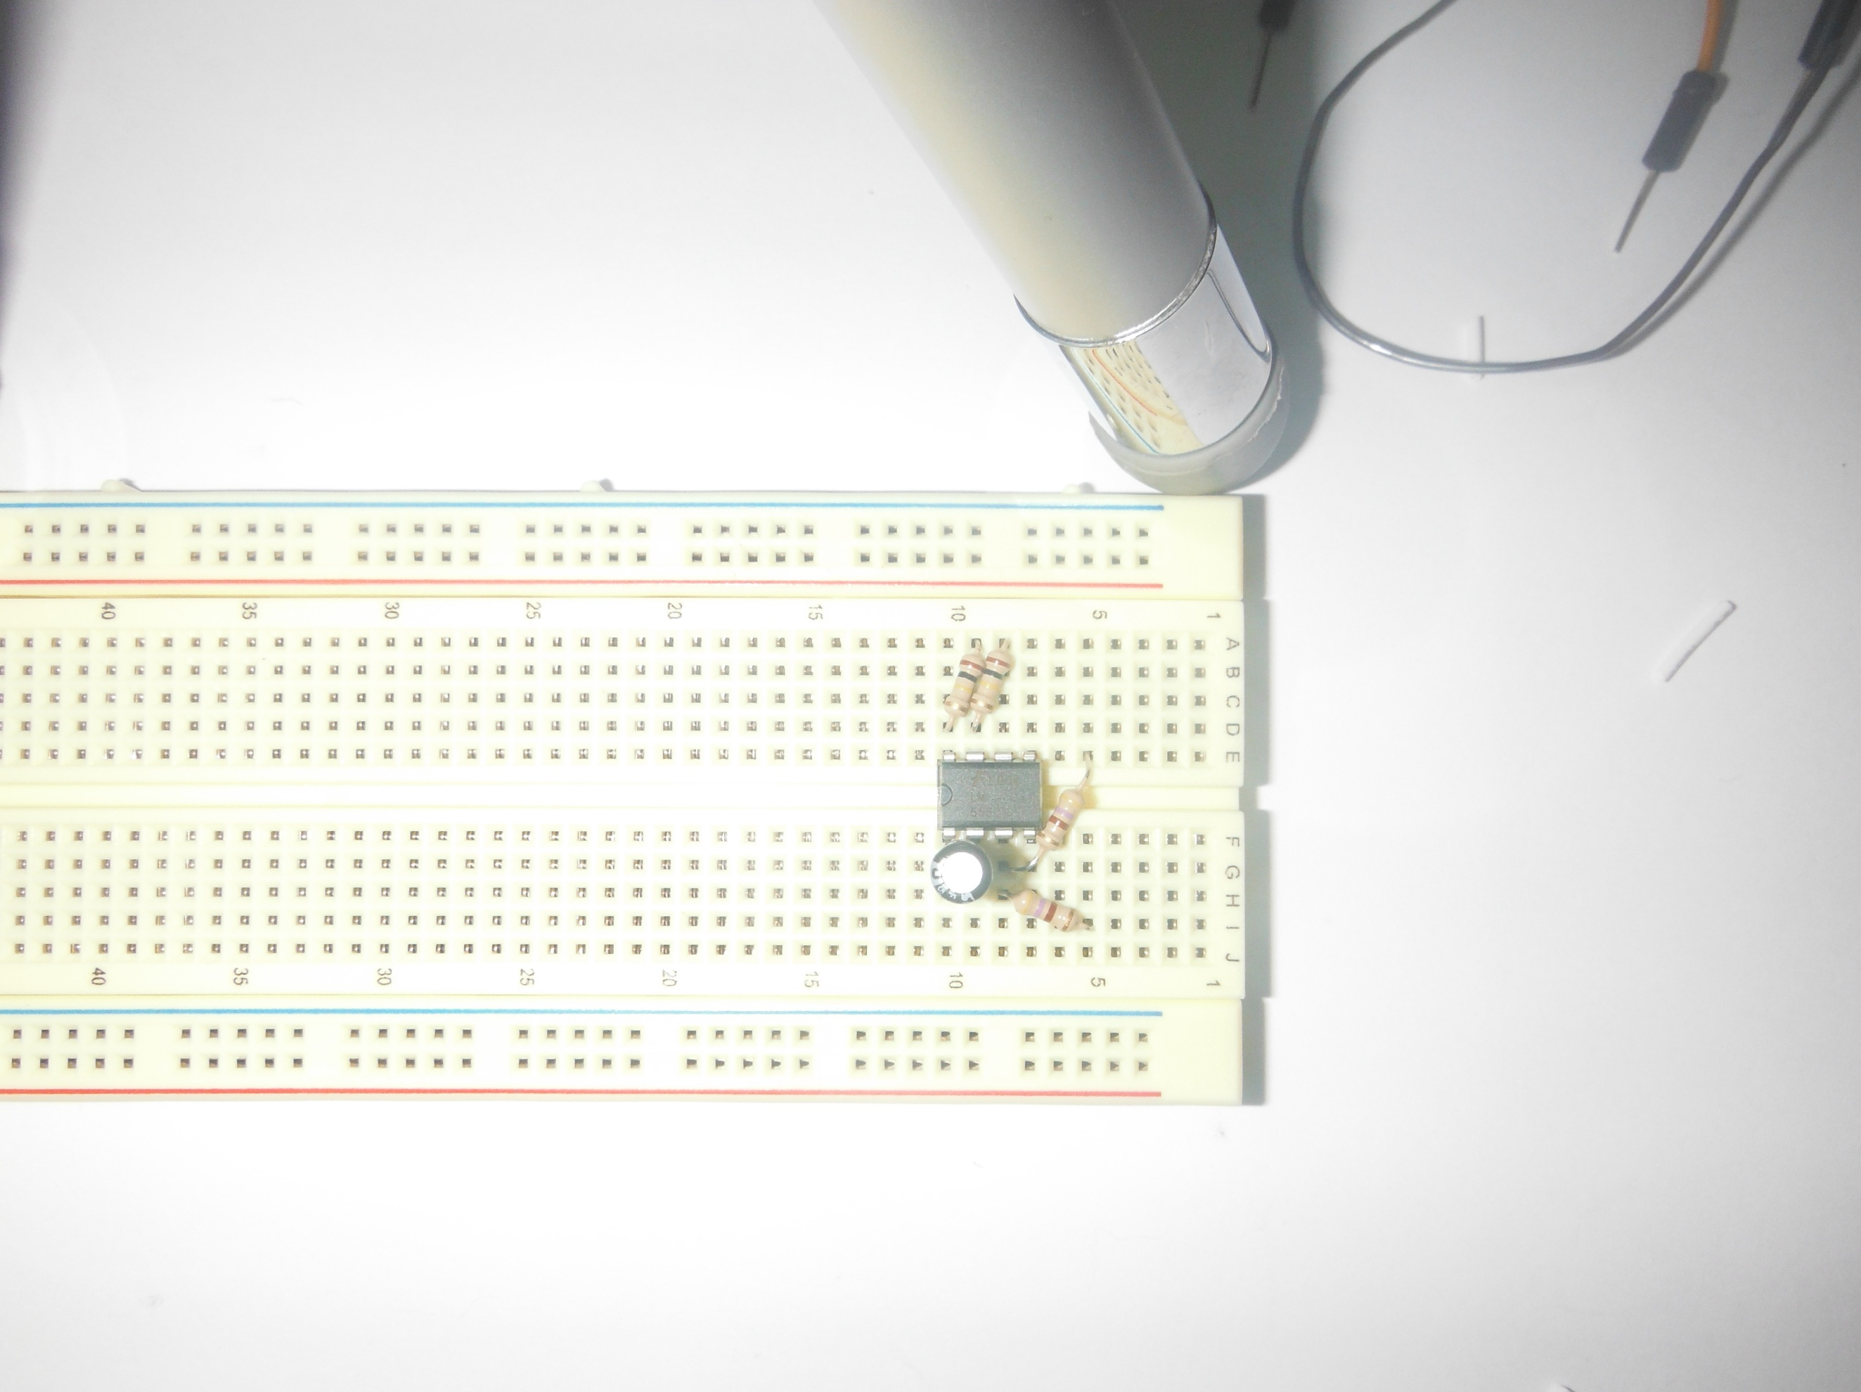

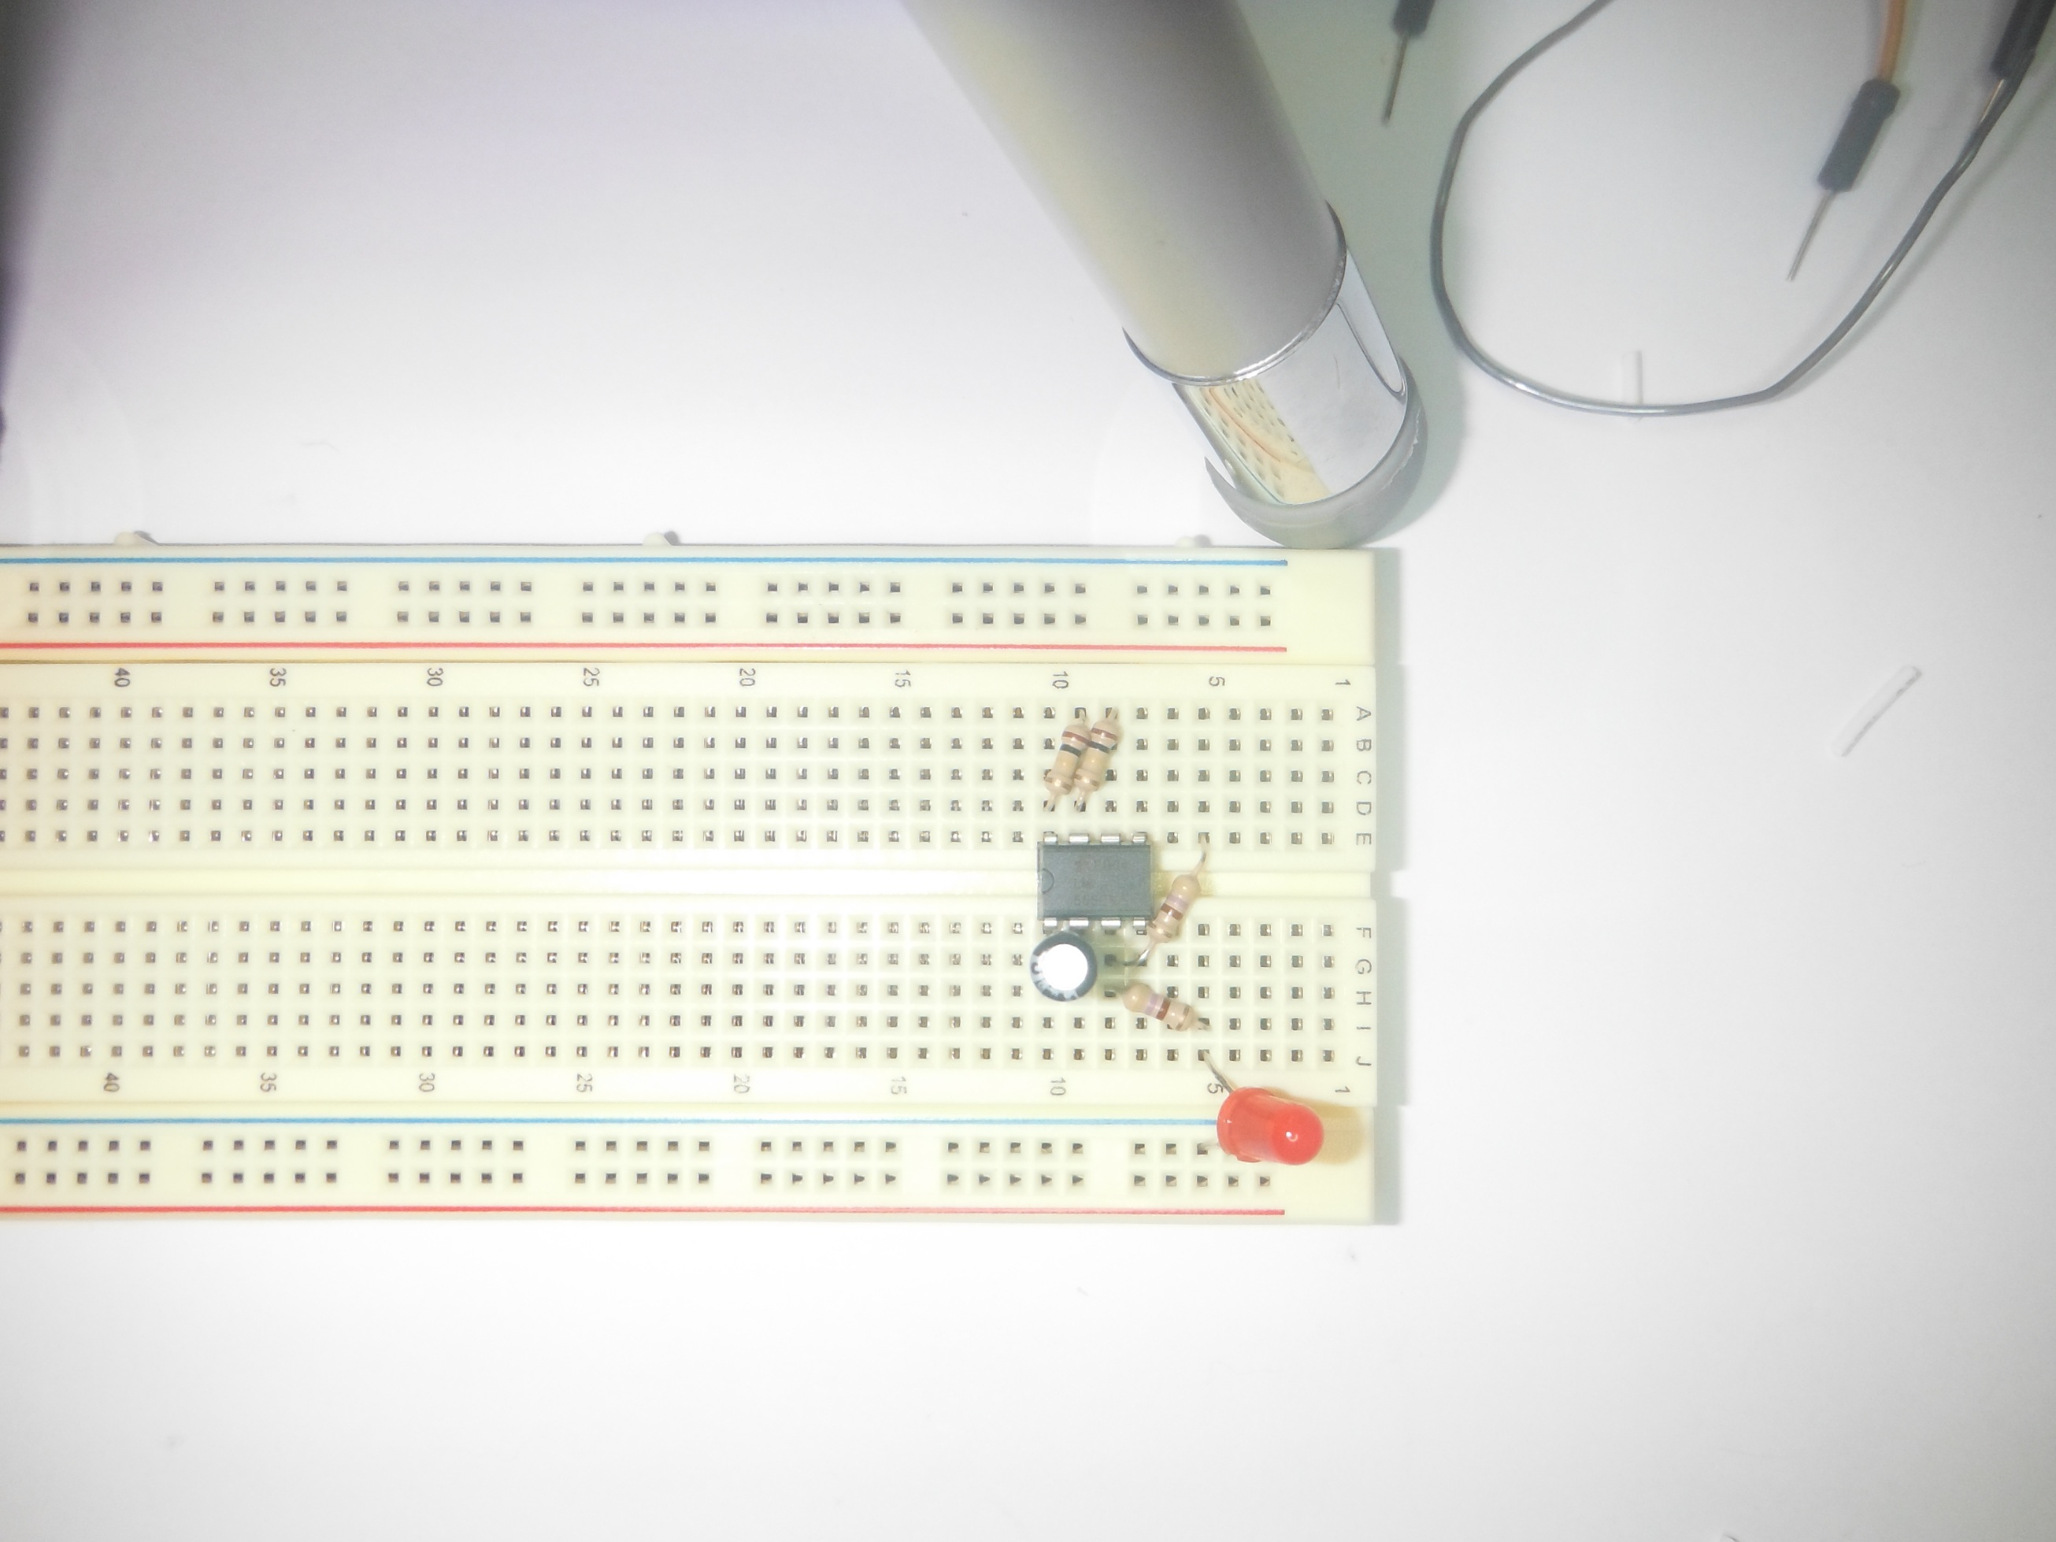

7) Insert RED led, Long Lead at J5, Short Lead at Ground Rail.  
Red LED J5+ to GR-

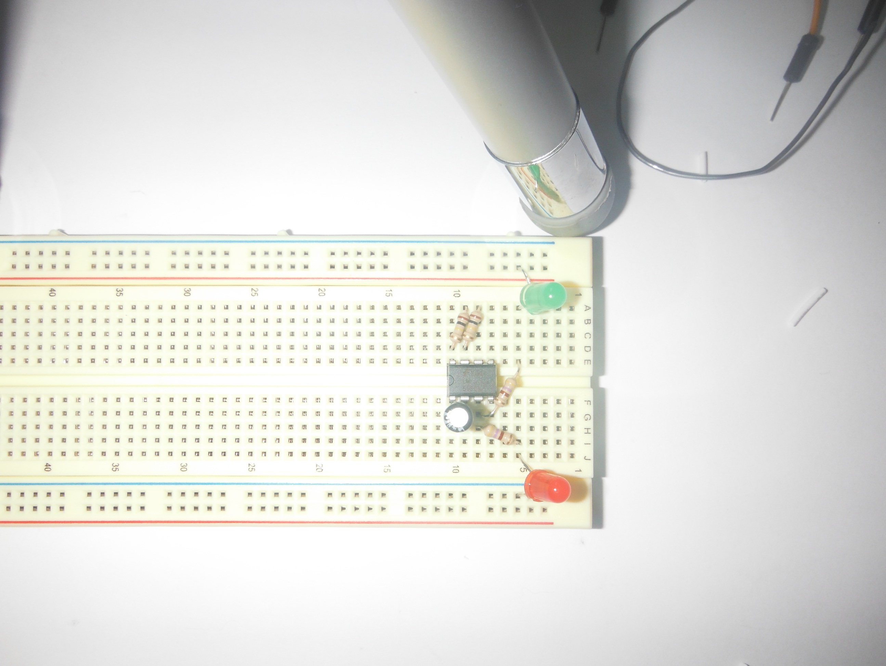

8) Insert Green LED, Long Lead at Positive Rail, Short Lead at A5.  
Green LED PR+ to A5-.

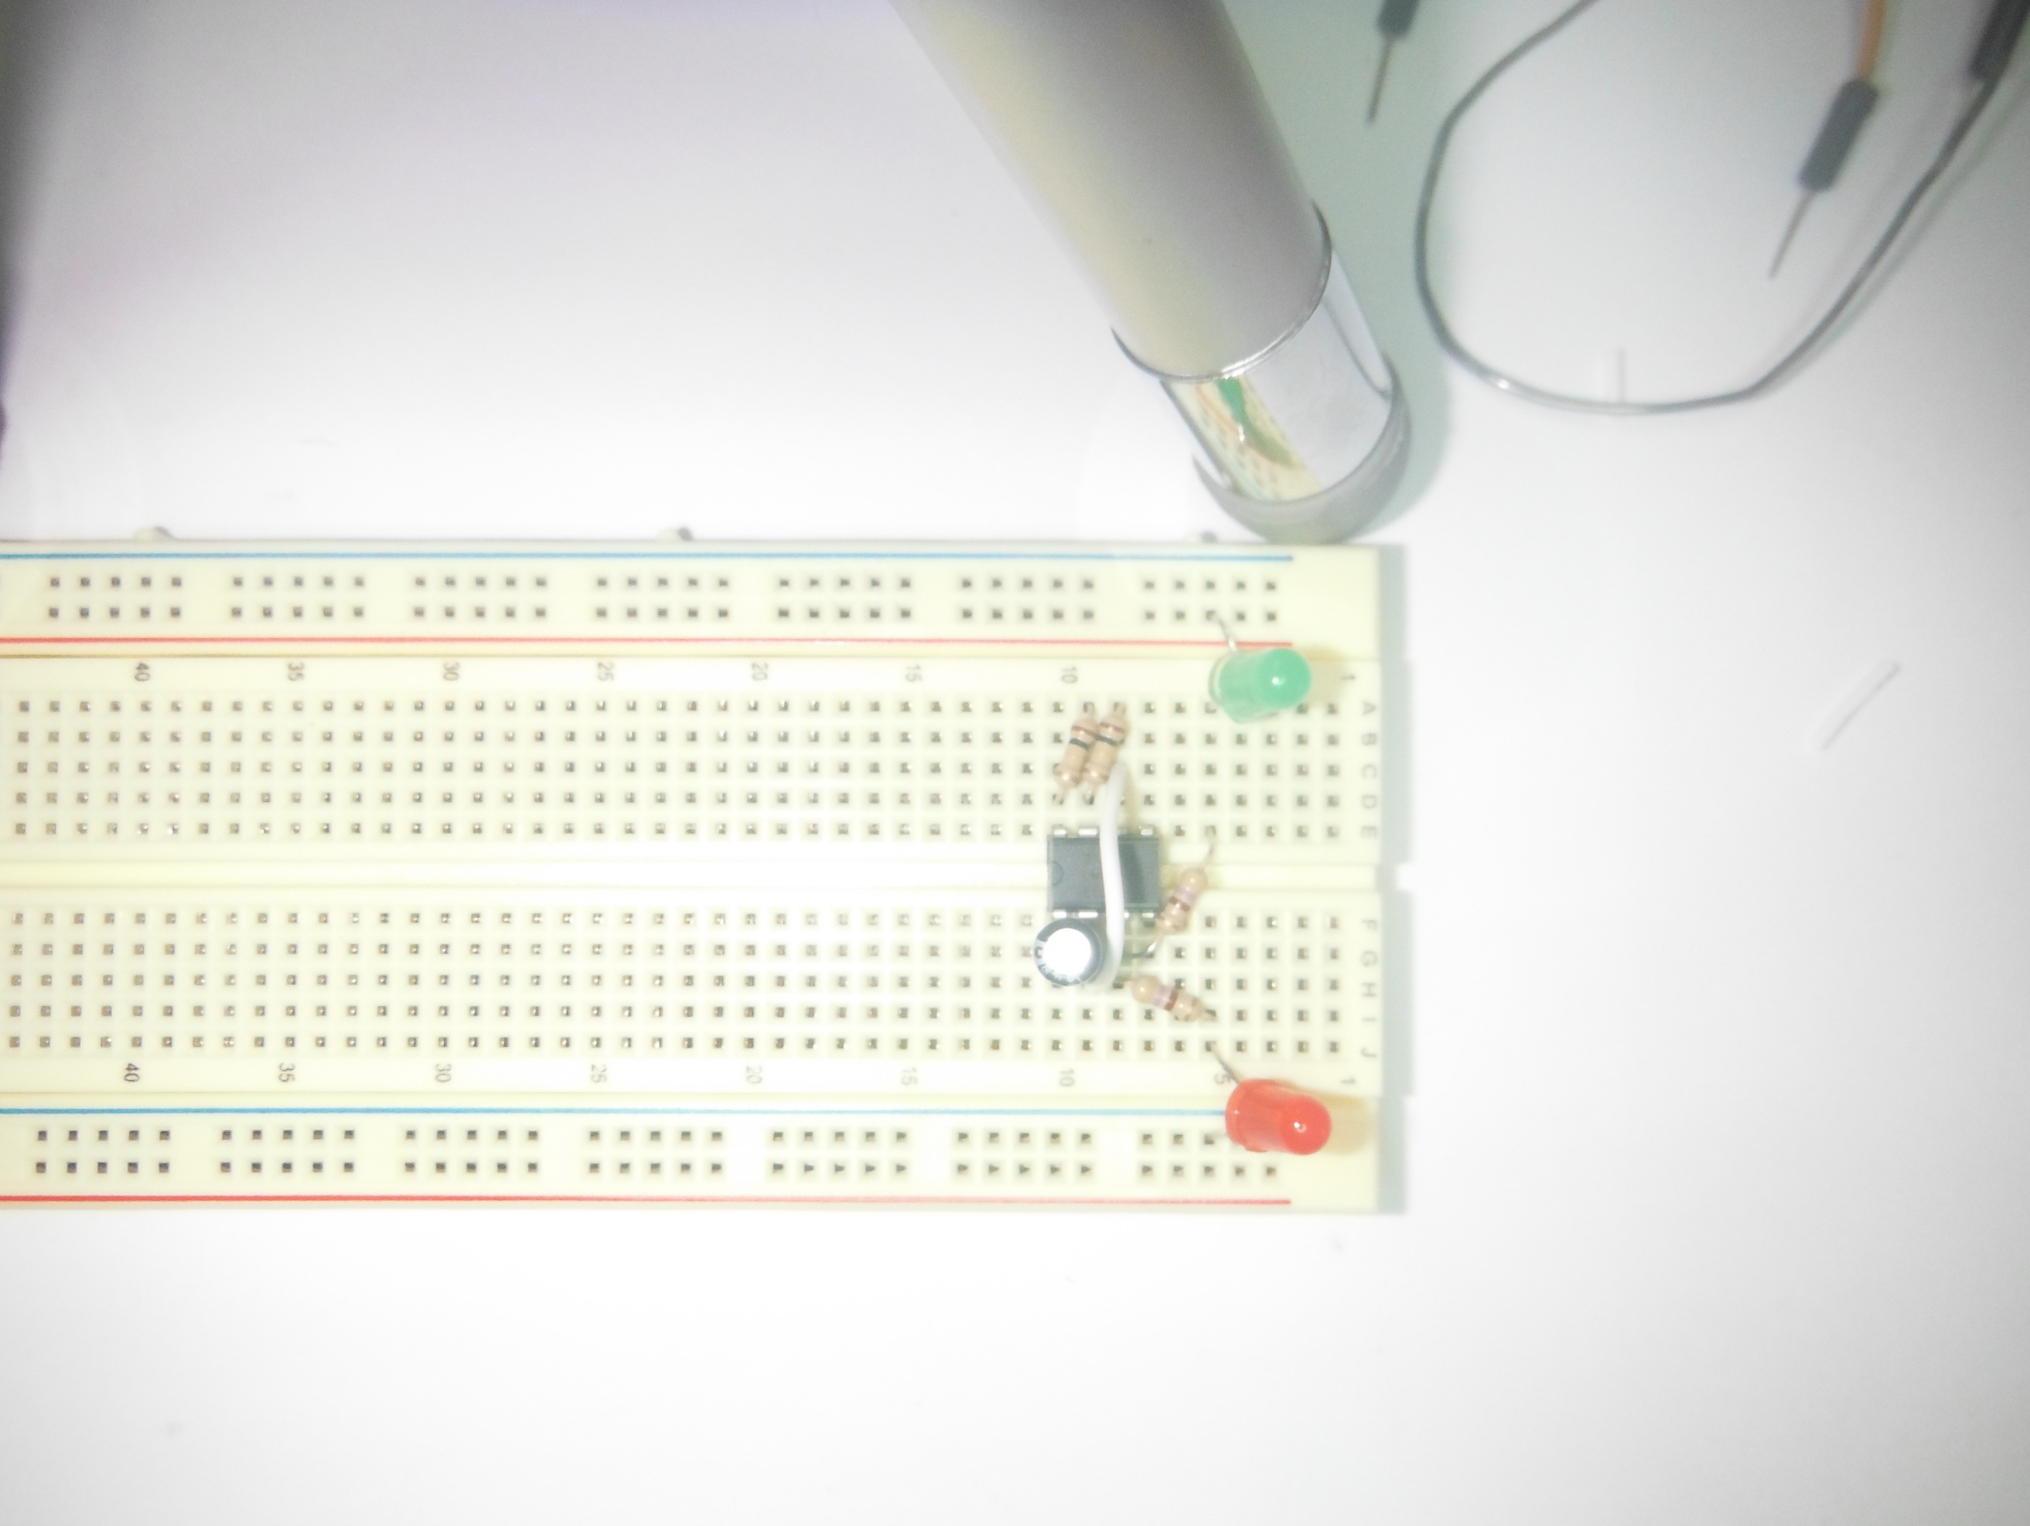9) Insert Jump from Pin 6 to Pin 2.  
Jumper from C8 to H9.

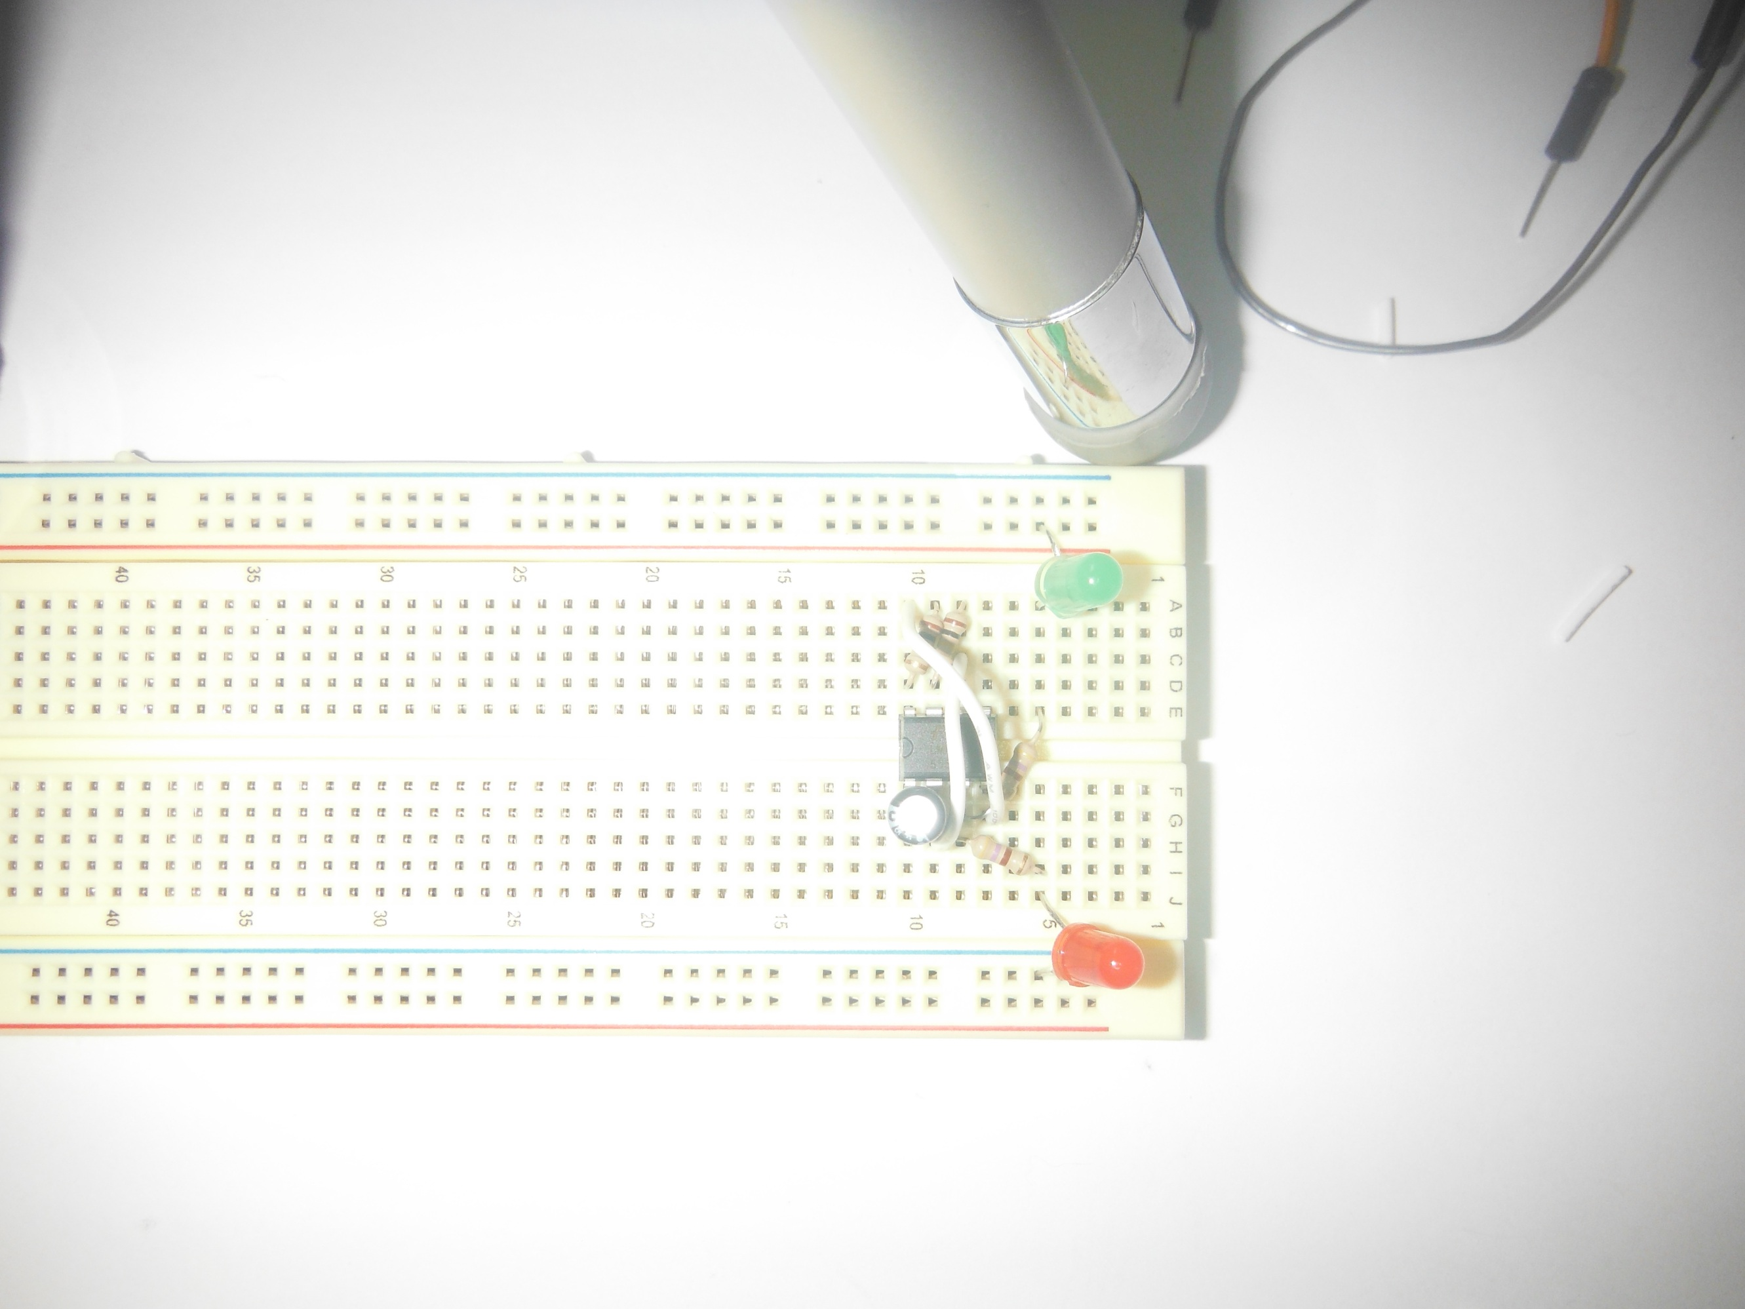

10) Insert Jumper from Pin 8 to Pin 4.  
Jumper from A10 to G7.

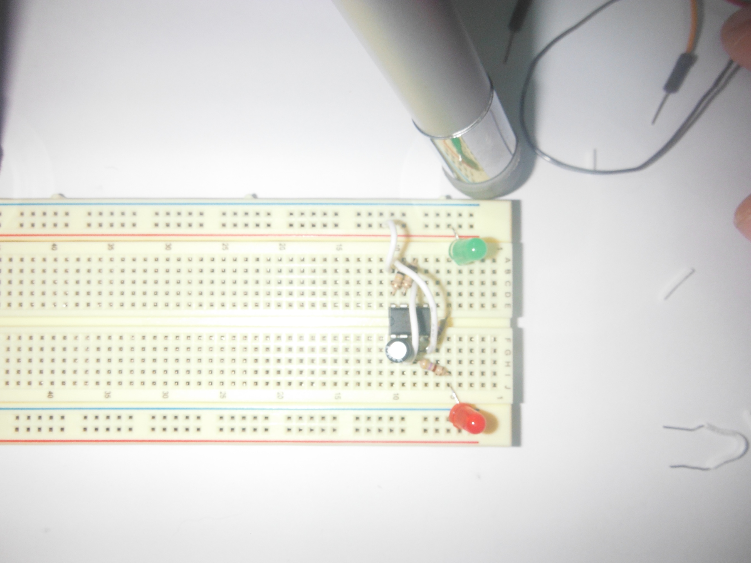  
  
  
11) Jumper from Pin 8 to Positive Rail.  
Jumper B10 to PR.

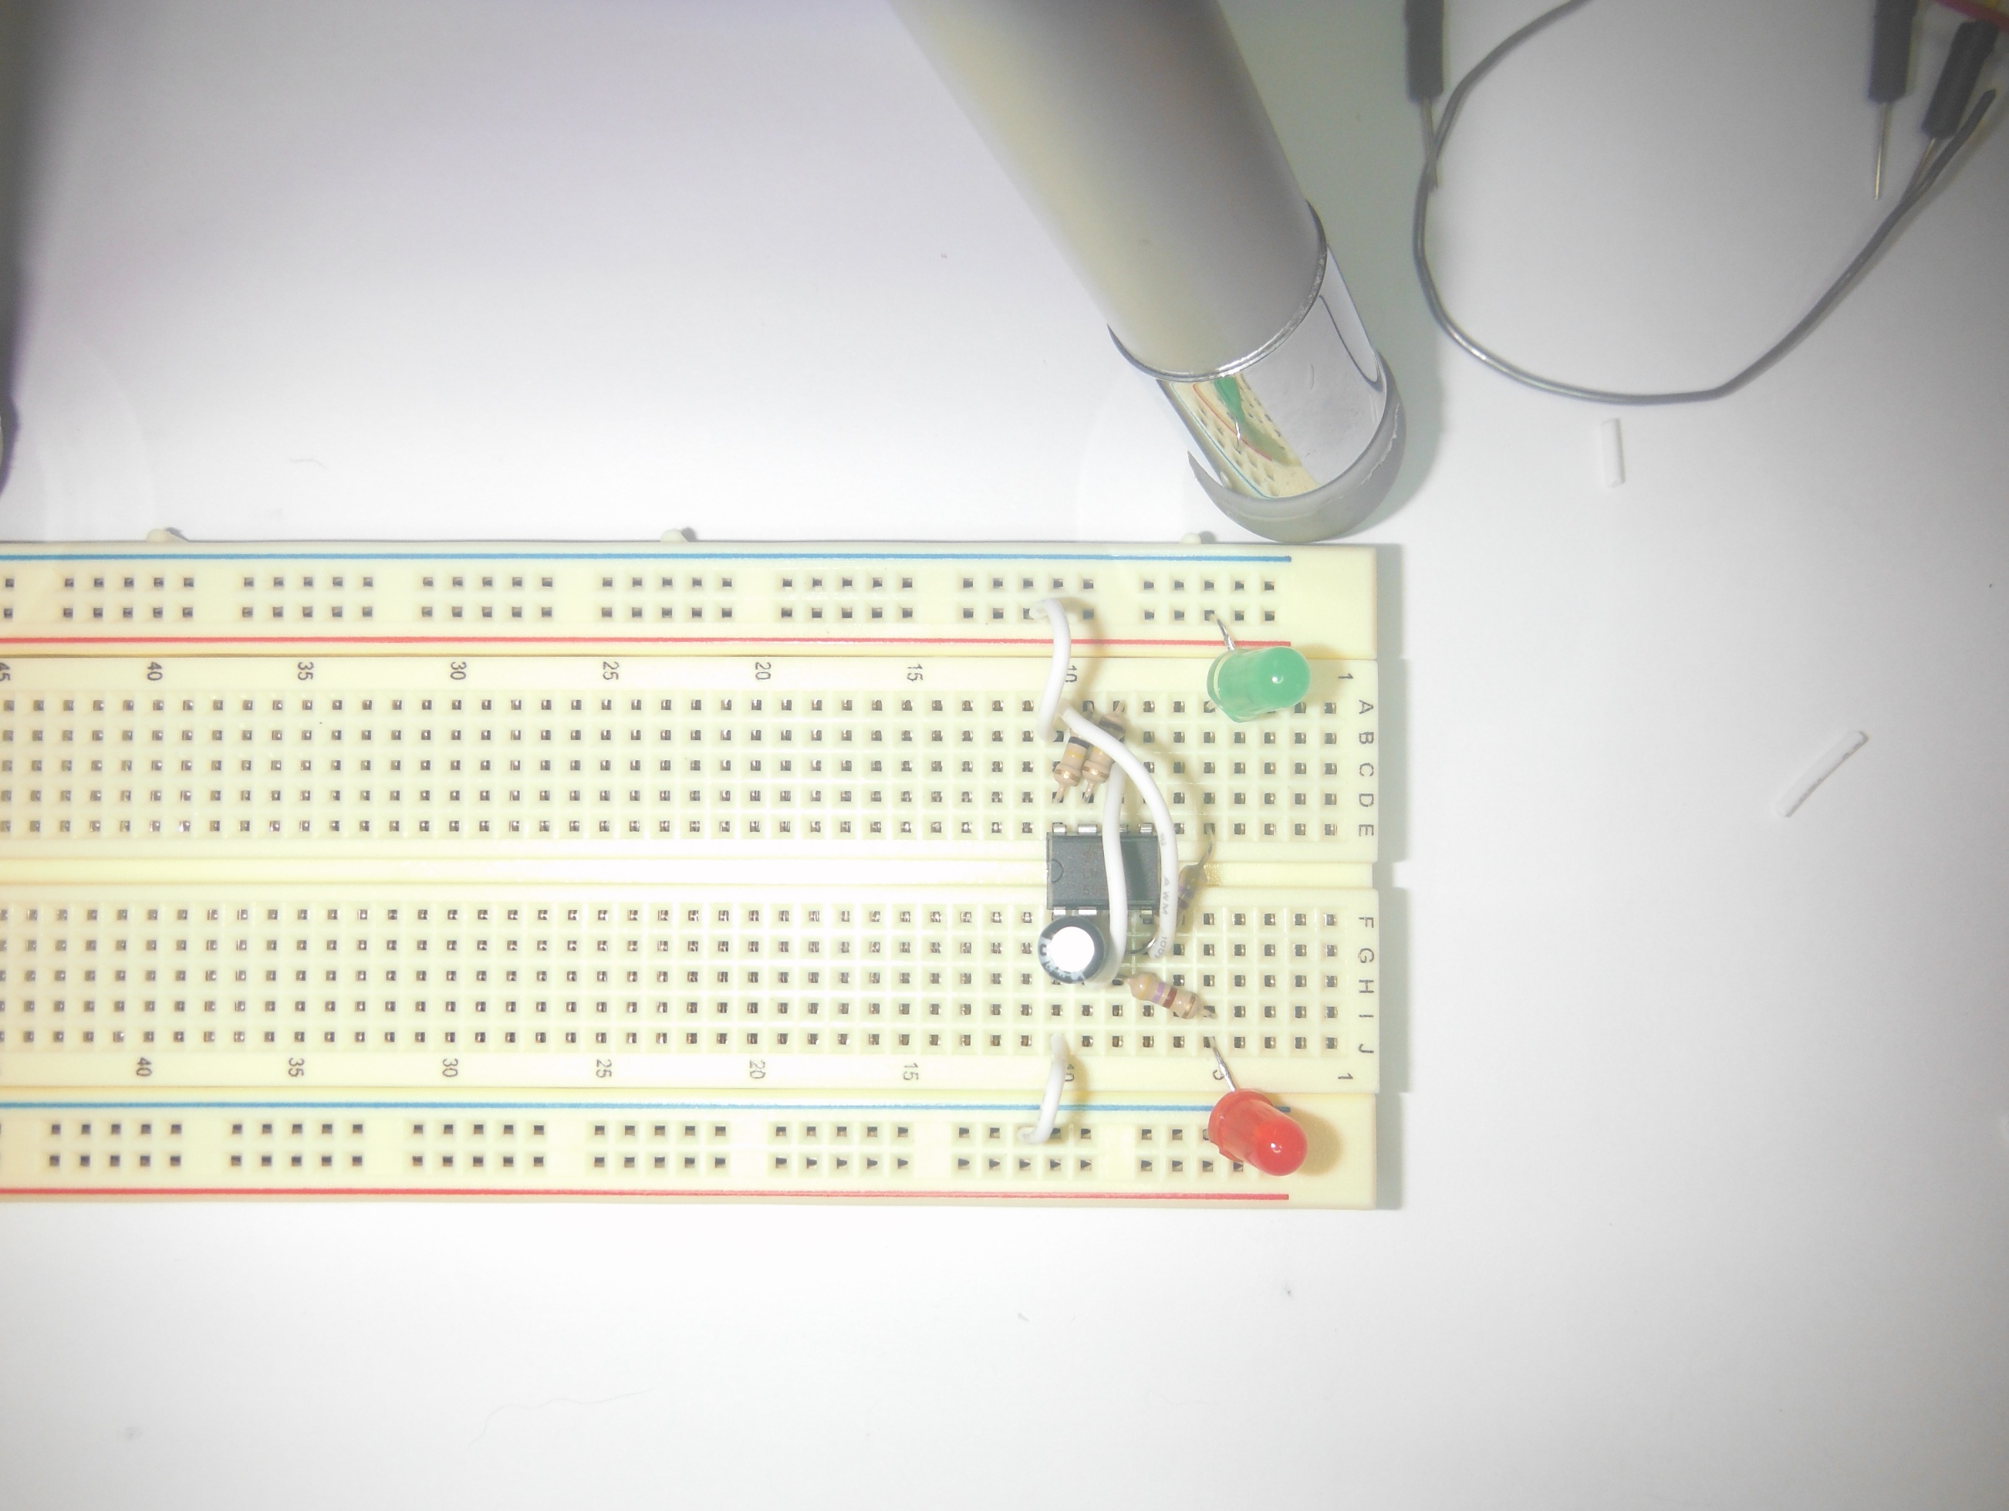  
12) Jumper Pin 1 to Negative Rail.  
Jumper J10 to NR.

13) Attach Battery Clip to Battery.  
Positive (Red) to Positive Rail  
Negative (Black) to Negative Rail.  
LEDs should immediately start to alternate, blinking slowly.  
